**LAMBDA ASSIGNMENT**

1.Write an application to perform basic arithmetic operations like add, subtract, multiply & divide. You need to define a functional interface first.

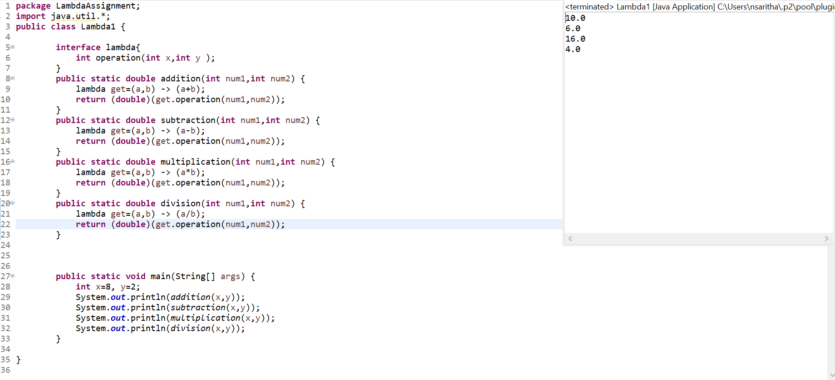

2.Write an application using lambda expressions to print Orders having 2 criteria implemented:

1.order price more than 10000

2.order status is ACCEPTED or COMPLETED.

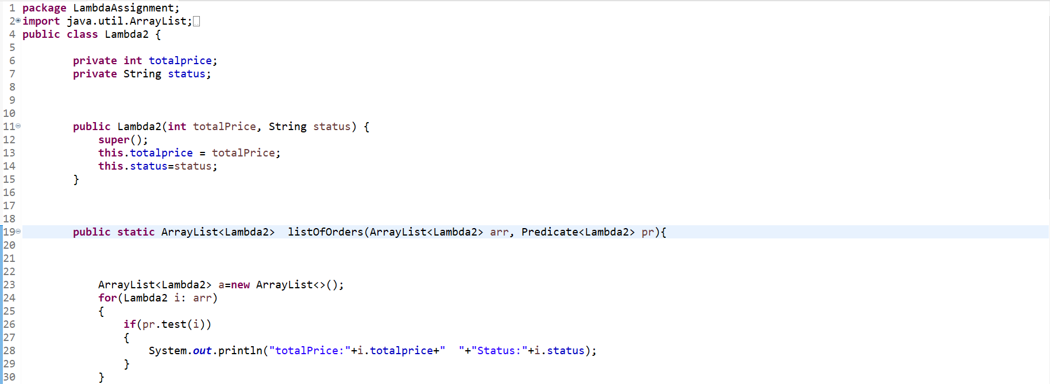

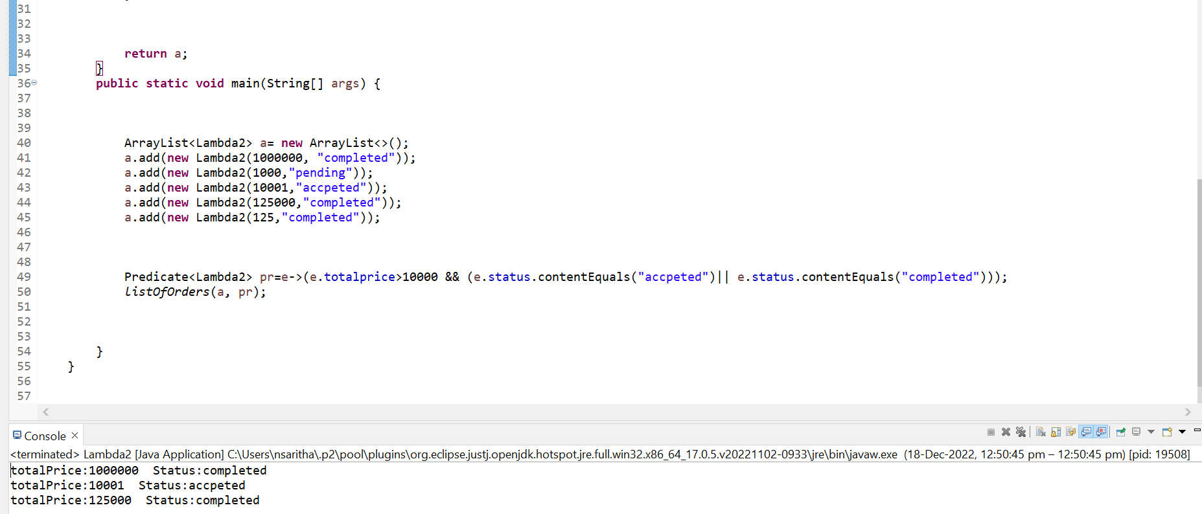

3.Use the functional interfaces Supplier, Consumer, Predicate & Function to invoke built-in methods from java API.

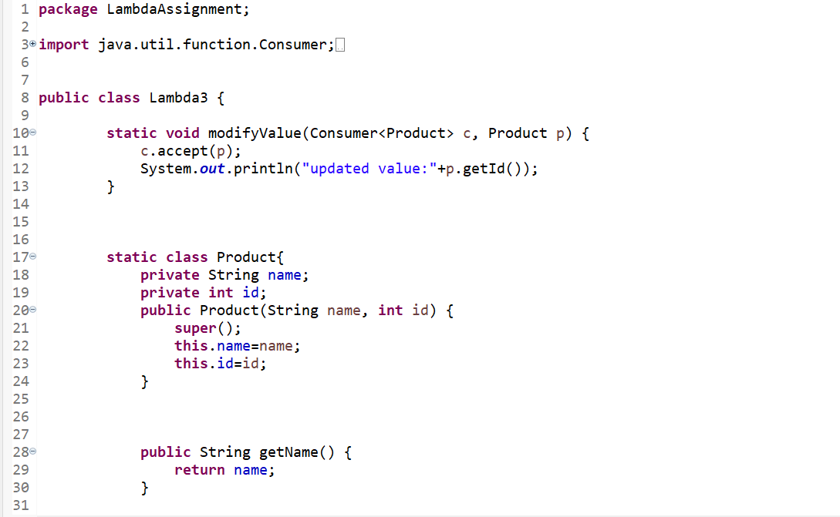

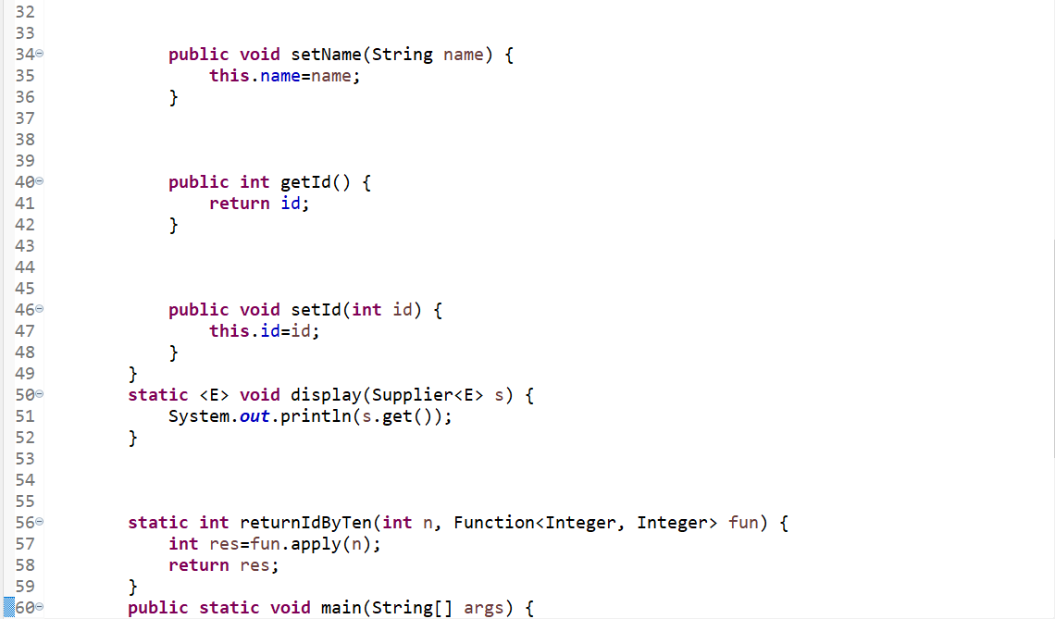

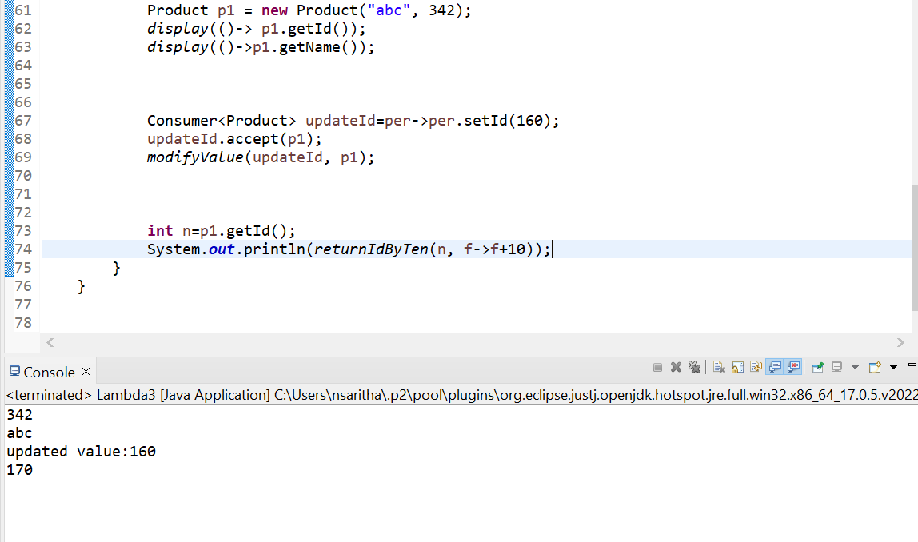

4. Remove the words that have odd lengths from the list.

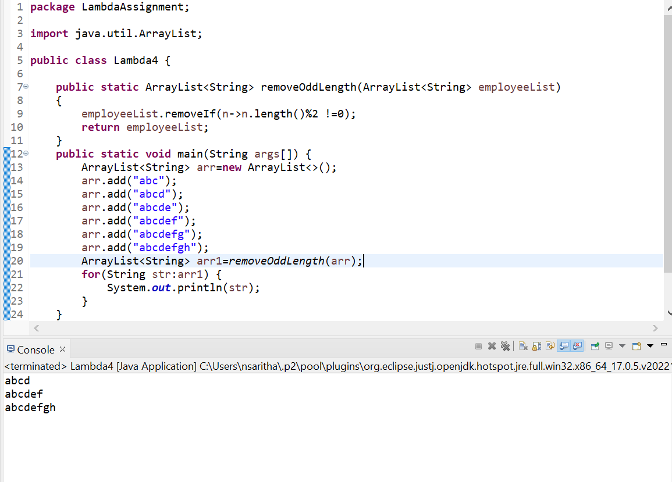

5. Create a string that consists of the first letter of each word in the list of strings provided.

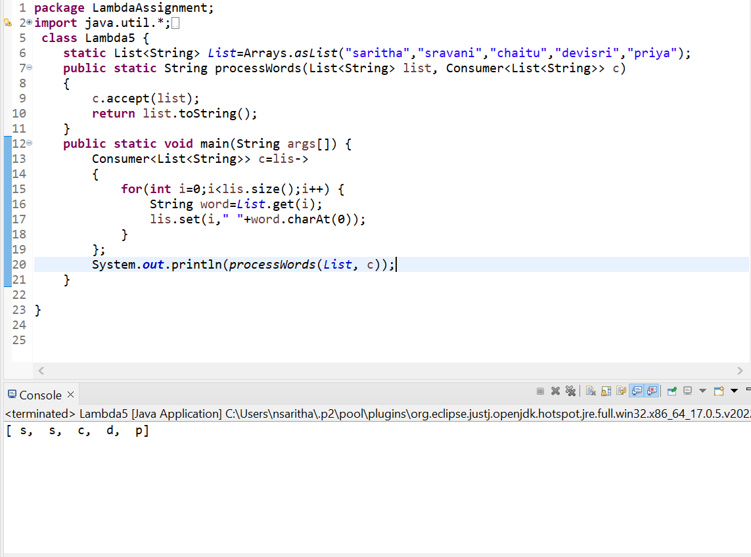

6.Replace every word in the list with its upper case equivalent. Use replaceAll() method & UnaryOperator interface.

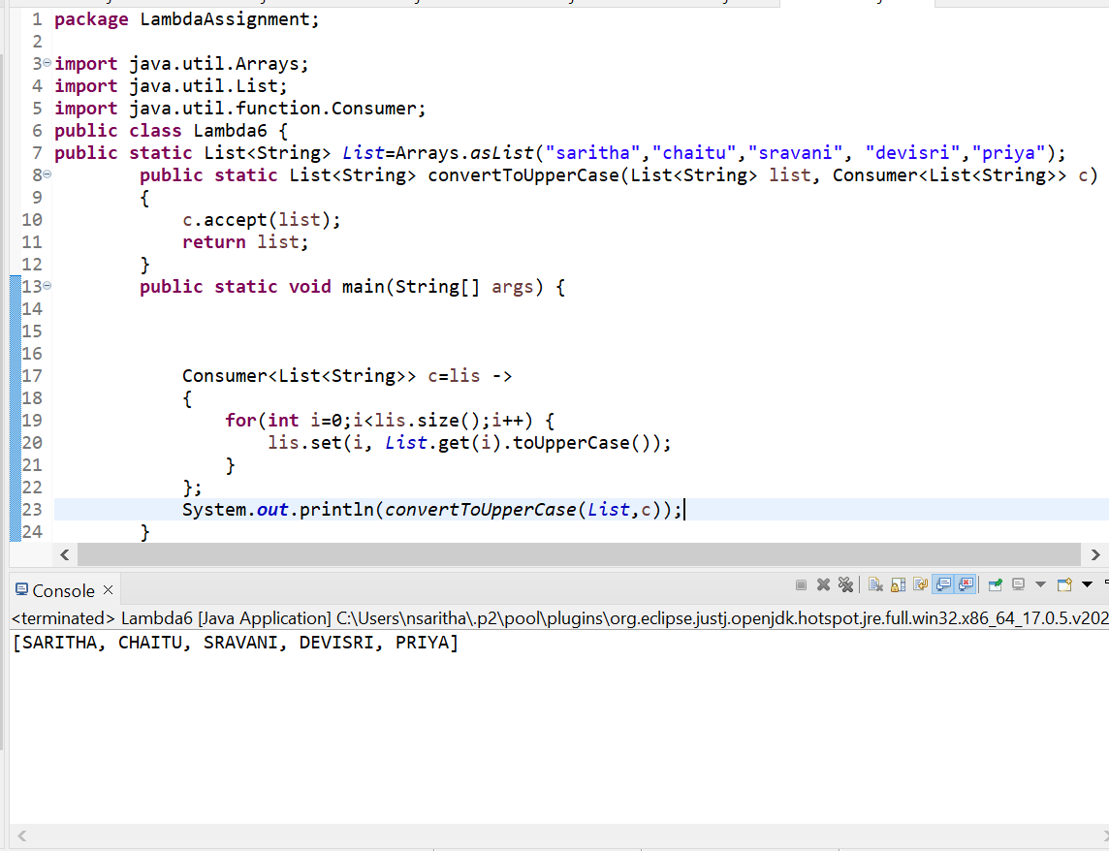

7.Convert every key-Value pair of the map into a string and append them all into a single String, in iteration order.

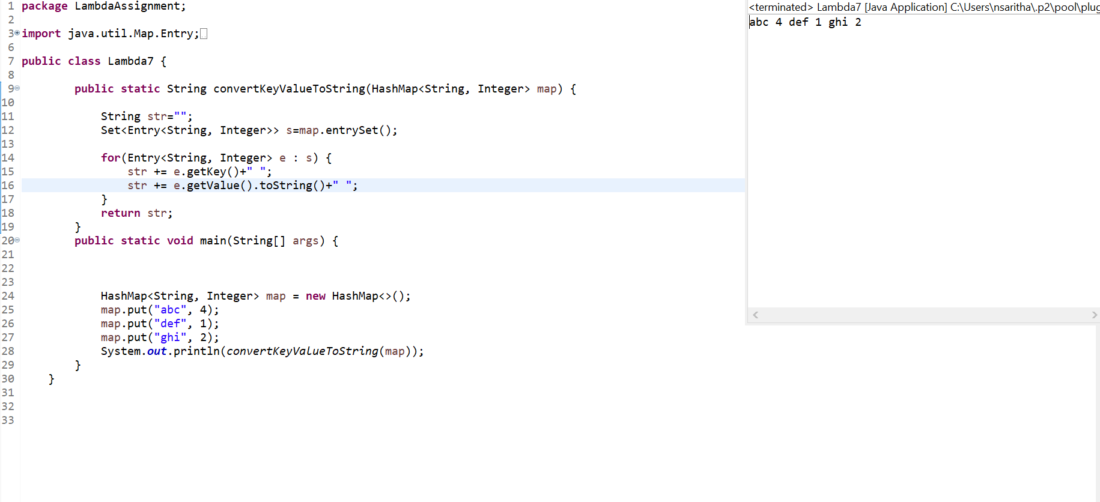

8. Create a new thread that prints the numbers from the list. Use class Thread & interface Consumer.

